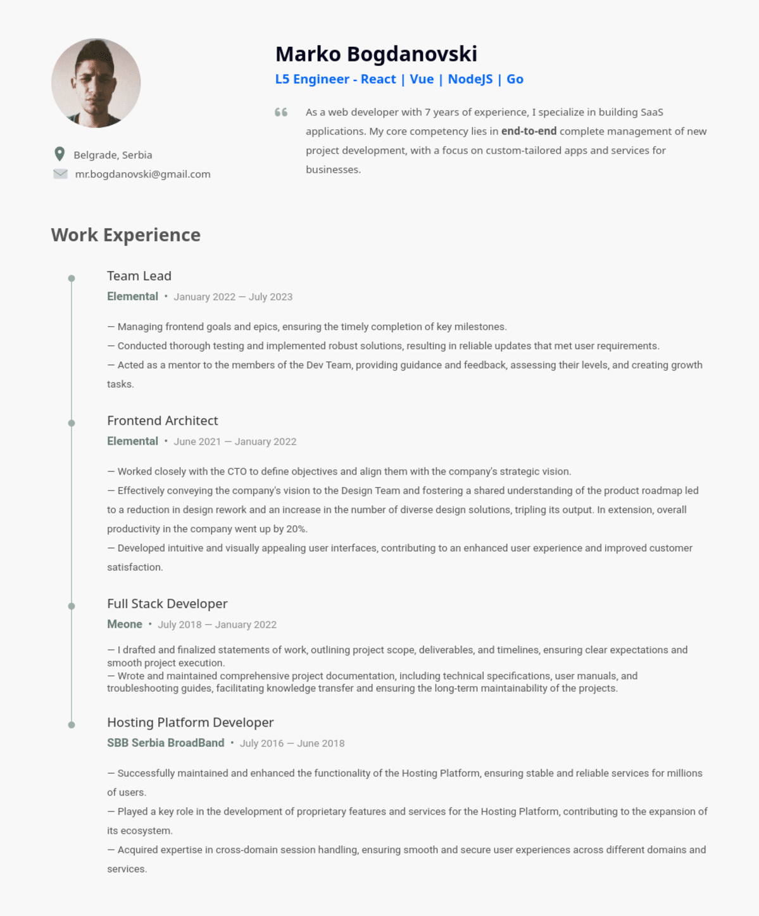
Belgrade, Serbia
mr.bogdanovski@gmail.com
Marko Bogdanovski
L5 Engineer - React | Vue | NodeJS | Go
66
As a web developer with 7 years of experience, I specialize in building SaaS applications. My core competency lies in end-to-end complete management of new project development, with a focus on custom-tailored apps and services for businesses.
Work Experience
Team Lead
Elemental January 2022 - July 2023
- Managing frontend goals and epics, ensuring the timely completion of key milestones.
- Conducted thorough testing and implemented robust solutions, resulting in reliable updates that met user requirements.
- Acted as a mentor to the members of the Dev Team, providing guidance and feedback, assessing their levels, and creating growth tasks.
Frontend Architect
Elemental June 2021 January 2022
- Worked closely with the CTO to define objectives and align them with the company's strategic vision.
- Effectively conveying the company's vision to the Design Team and fostering a shared understanding of the product roadmap led
to a reduction in design rework and an increase in the number of diverse design solutions, tripling its output. In extension, overall productivity in the company went up by 20%.
- Developed intuitive and visually appealing user interfaces, contributing to an enhanced user experience and improved customer satisfaction.
Full Stack Developer
Meone
July 2018 January 2022
- I drafted and finalized statements of work, outlining project scope, deliverables, and timelines, ensuring clear expectations and smooth project execution.
- Wrote and maintained comprehensive project documentation, including technical specifications, user manuals, and troubleshooting guides, facilitating knowledge transfer and ensuring the long-term maintainability of the projects.
Hosting Platform Developer
SBB Serbia Broad Band July 2016 June 2018
- Successfully maintained and enhanced the functionality of the Hosting Platform, ensuring stable and reliable services for millions of users.
- Played a key role in the development of proprietary features and services for the Hosting Platform, contributing to the expansion of its ecosystem.
- Acquired expertise in cross-domain session handling, ensuring smooth and secure user experiences across different domains and
services.

